LAB PROGRAMS

1. Create a new process by invoking the appropriate system call. Get the process
identifier of the currently running process and its respective parent using
system calls and display the same using a C program.
PROGRAM:
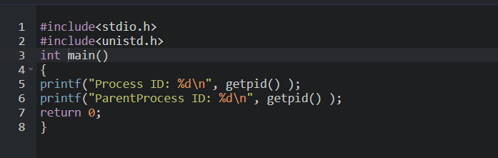
OUTPUT:
